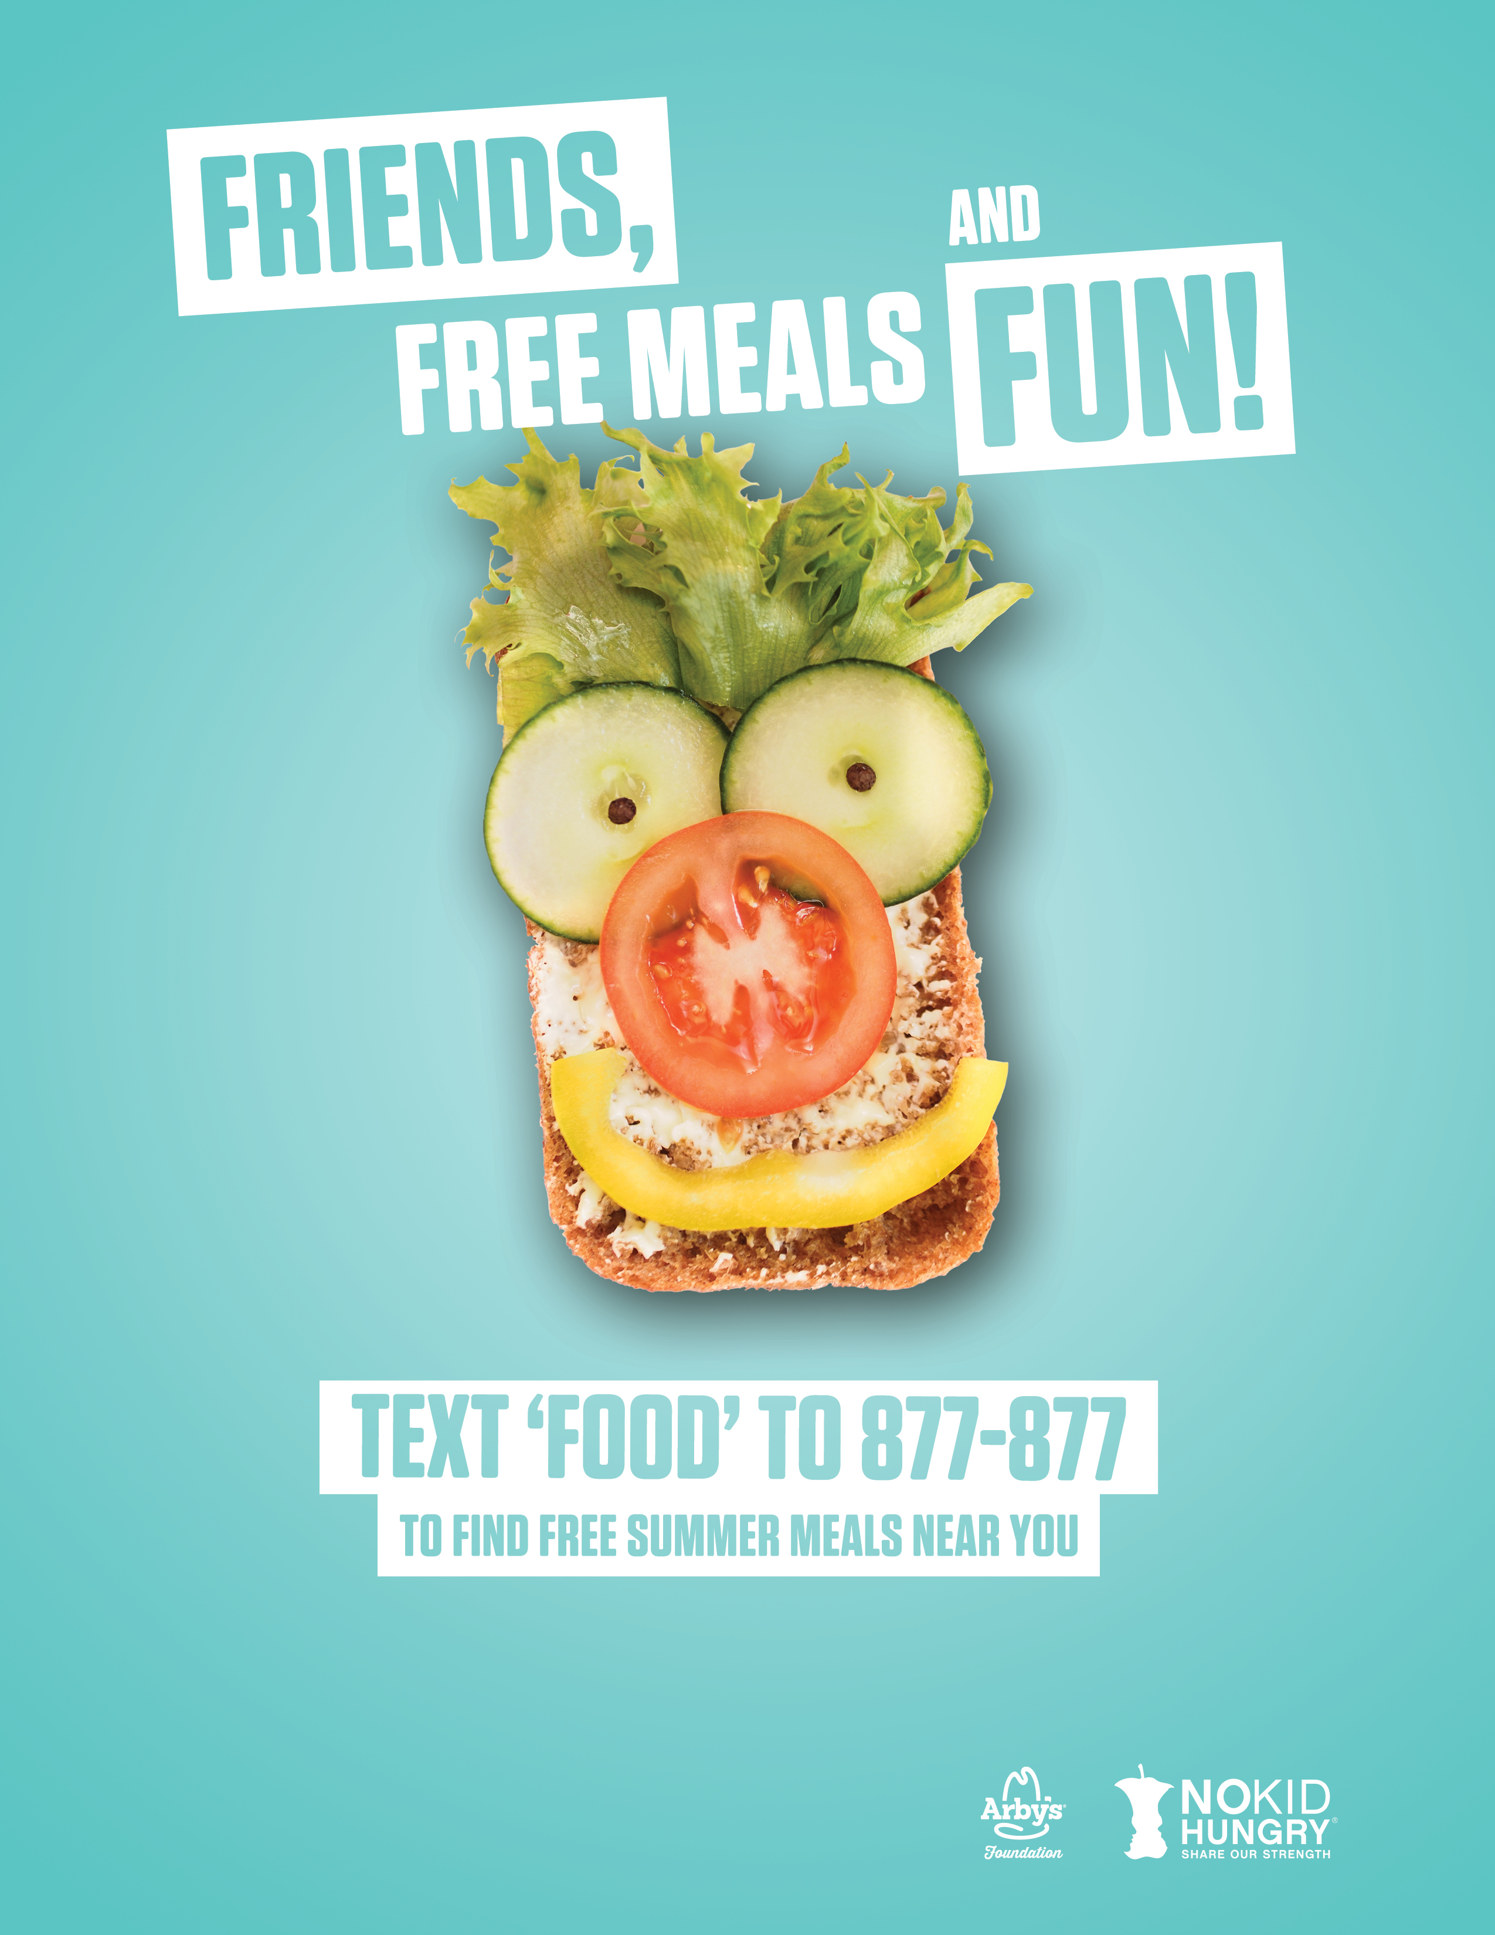

**Pine Acres Community Center, 402 McLean Street, Fuquay-Varina, NC 27526**

**Tuesdays and Thursdays: June 20 - August 10**

**11am -12 noon - fun physical activities, 12 noon – 1 pm – hot lunch**

Bryan Haynes: bmh1919@gmail.com

Dana Orr: d.orr@poehealth.org