“Strength for the Journey”
2019 Camp Braveheart

…a one-day camp experience, sponsored by Amedisys Hospice, for children ages 6-16 who have experienced the death of a loved one.
Join our trained professionals and volunteer “buddies” for a day of laughter, tears, sharing, remembering and healing. Helping children “create stepping stones from their stumbling blocks.”
Where? New Hope Camp and Conference Center located at 4805 NC- 86 South, Chapel Hill, NC.
When? Saturday, September 14, 2019, 9:00 am – 5:30 pm Applications will be accepted beginning March 15, 2019 through August 15, 2019. Request an application via the email addresses or the phone number listed below.
Cost? There is no cost for camp. The day includes a T-shirt, light breakfast, lunch, snacks and beverages.
Referrals are welcome from parents, counselors, teachers, ministers, or other concerned persons.
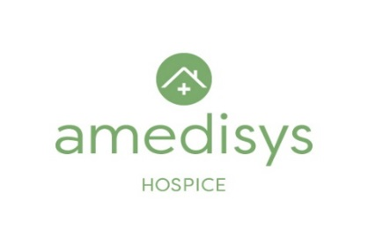
For more information or to request an application, please contact: Kathy Barham, Elesha Dye, or Laura Davis, Amedisys Hospice Camp Coordinators at (919) 773-4865 or by email to katherine.barham@amedisys.com or elesha.dye@amedisys.com

